FoundIt: Your Campus Return & Recovery

[1]Sanket S. [Raskar-sanketraskar25@gmail.com](mailto:Raskar-sanketraskar25@gmail.com) [2]Sanket S. [Chougule-sanketchougule@gmail.com](mailto:Chougule-sanketchougule@gmail.com) [3]Siddhesh I. Kamble- [kamblesiddhesh09@gmail.com](mailto:kamblesiddhesh09@gmail.com) [4]Ganesh S. [Kokate-ganeshkokate25@gmail.com](mailto:Kokate-ganeshkokate25@gmail.com) [5]Vishal N. Kshirsagar [-vishalkshirsagarmain@gmail.com](mailto:-vishalkshirsagarmain@gmail.com)

*Department of Computer Science and Engineering , Dr. D. Y. Patil Pratisthan’s College Of Engineering, Salokhenagar, Kolhapur.*

***Abstract*— The abstract briefly summarizes the problem, solution, and significance of *FoundIt: Your Campus Return & Recovery*. This web-based platform addresses inefficiencies in traditional lost and found systems on college campuses by digitizing the process of reporting and retrieving lost items. Users can search for or report items, leveraging real-time notifications and a secure verification process. Features like multi-language support and automated notifications enhance accessibility and usability, providing a scalable, efficient, and user-friendly solution.**

***Keywords: Lost and Found System, Campus, Multi-language Support, Digital Platform, Verification Process.***

1. Introduction

The traditional lost and found systems used on college campuses often rely on manual processes, which are time-consuming, inefficient, and inconvenient for both students and staff. In these systems, individuals who lose items must repeatedly visit a designated office to inquire about their belongings, while those who find items are required to deposit them at the same location. This reliance on physical interactions and outdated record- keeping methods results in significant delays, misplaced items, and the potential for wrongful claims due to the lack of a secure verification process. Moreover, the absence of remote access or real-time updates adds to the frustration of users, especially those with busy schedules or accessibility challenges.

*FoundIt: Your Campus Return & Recovery* addresses these shortcomings by introducing a fully digital, web-based solution that streamlines the

process of reporting and retrieving lost items. The platform allows users to report found items with partial details and search for lost belongings using filters such as item type, color, and location. To ensure security, it incorporates a verification system based on security questions, significantly reducing the risk of fraudulent claims. With features like multi-language support, real-time notifications, and an administrative panel for resolving disputes, *FoundIt* aims to modernize lost and found management, offering a more user-friendly, efficient, and reliable solution tailored to the needs of a diverse campus community.

1. Finding lost items

Losing personal belongings is common on college campuses, with items like stationery, gadgets, and wallets often going missing. The vast campus environment makes retracing steps or pinpointing locations difficult, and traditional methods like physically revisiting spots or asking others are time-consuming and inefficient [3].

*FoundIt: Your Campus Return & Recovery* leverages technology to streamline item recovery. Users can search for lost items by entering details like type, color, or location, while those who find items can report them discreetly [7]. Mobile apps like *Mafqudat* and *Find Mine* have shown how digital solutions can improve recovery efficiency through direct reporting and search features [1], [2].

**XXX-X-XXXX-XXXX-X/XX/$XX.00 ©20XX IEEE**

1. LOCATOR TECHNOLOGY

Campus lost-and-found systems typically rely on manual processes, requiring repeated visits to offices for reporting or retrieving items. This is inefficient and prone to errors [5].

*FoundIt* eliminates these inefficiencies by allowing users to report and search for items through a centralized, digital platform. The system automatically notifies users when their item is found, reducing delays and staff workload [6], [7]. The platform can be enhanced with IoT and RFID technologies for more precise tracking of lost items in real-time [9], [10].

These technologies, including RFID and BLE tags, are already showing promise in tracking items in both indoor and outdoor spaces [4], further enhancing the *FoundIt* system's potential for faster, more accurate recovery.

1. FoundIt System

*FoundIt: Your Campus Return & Recovery* is a web-based platform designed to modernize and streamline the lost and found process on college campuses. Unlike the traditional manual system, which relies on repeated physical visits and basic record-keeping, the proposed system introduces a digital approach to improve efficiency, accessibility, and security.

The platform allows users to report and search for lost and found items online. When a user finds a misplaced item, they can upload partial details (such as type, color, or location) to the system without revealing sensitive information. Conversely, users who have lost items can search the platform using filters to find potential matches. To ensure that items are returned to their rightful owners, the system incorporates a secure verification process using security questions or unique identifiers. Real-time notifications inform users about updates on their reported or searched items, reducing delays and the need for frequent follow-ups.

With its multi-language support, *FoundIt* caters to a diverse campus community, ensuring that language barriers do not hinder users from utilizing the platform. The system also includes an administrative panel for campus staff to manage disputes and oversee unresolved claims. By automating the lost and found process, *FoundIt* not only saves time for users but also reduces the workload of administrative staff, offering a seamless and user-friendly experience tailored to college environments.

*A. System design*

The design of *FoundIt: Your Campus Return & Recovery* follows a logical flow that integrates user interactions, data processing, and secure verification to streamline the lost and found process on a college campus. The system begins with **user authentication**, where students, faculty, and staff can register and log in to the platform. The authentication mechanism ensures secure access to features like reporting lost items, submitting found item details, and searching for matches.

Users are authenticated via encrypted credentials, and role-based access control differentiates regular users from administrators who handle dispute resolutions.

Once authenticated, users can interact with the platform’s intuitive interface to either report or search for items. The **lost item reporting module** enables users to log details such as item type, color, and approximate location. Similarly, the **found item reporting module** allows users to upload partial details of found items while withholding specific identifying characteristics for security purposes. All item data is sent to the back-end, where it is processed and stored in the database. This centralized repository ensures easy retrieval and efficient searching for matches.

The **search functionality** is a core component of the system, enabling users to filter and query the database for potential matches. Users who have lost items can search by various attributes like date, item type, or location. The system compares lost and found item details using predefined algorithms to identify possible matches. When a match is detected, both the owner and the finder are notified in real time through in-app notifications or email alerts, minimizing delays in communication and retrieval.

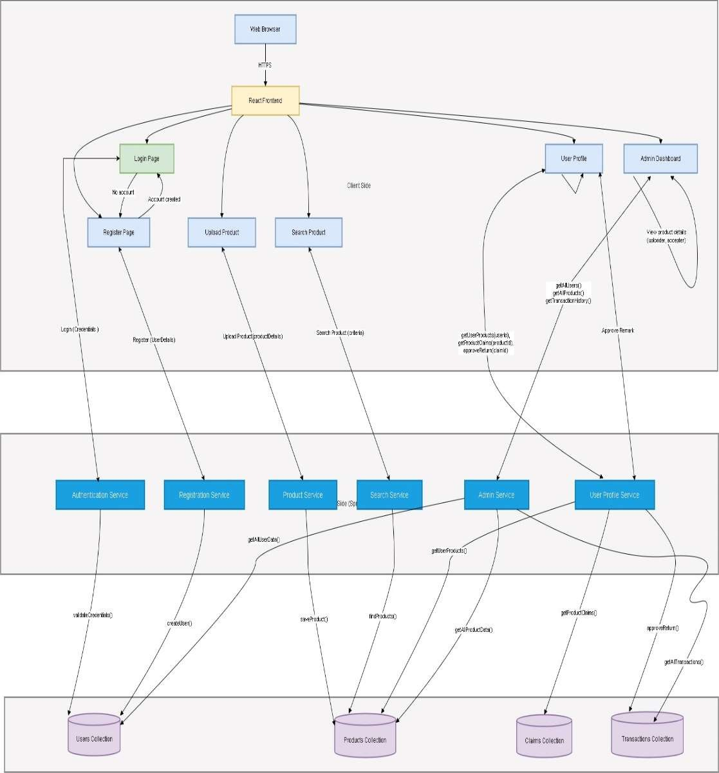

**Figure 1: System diagram.**

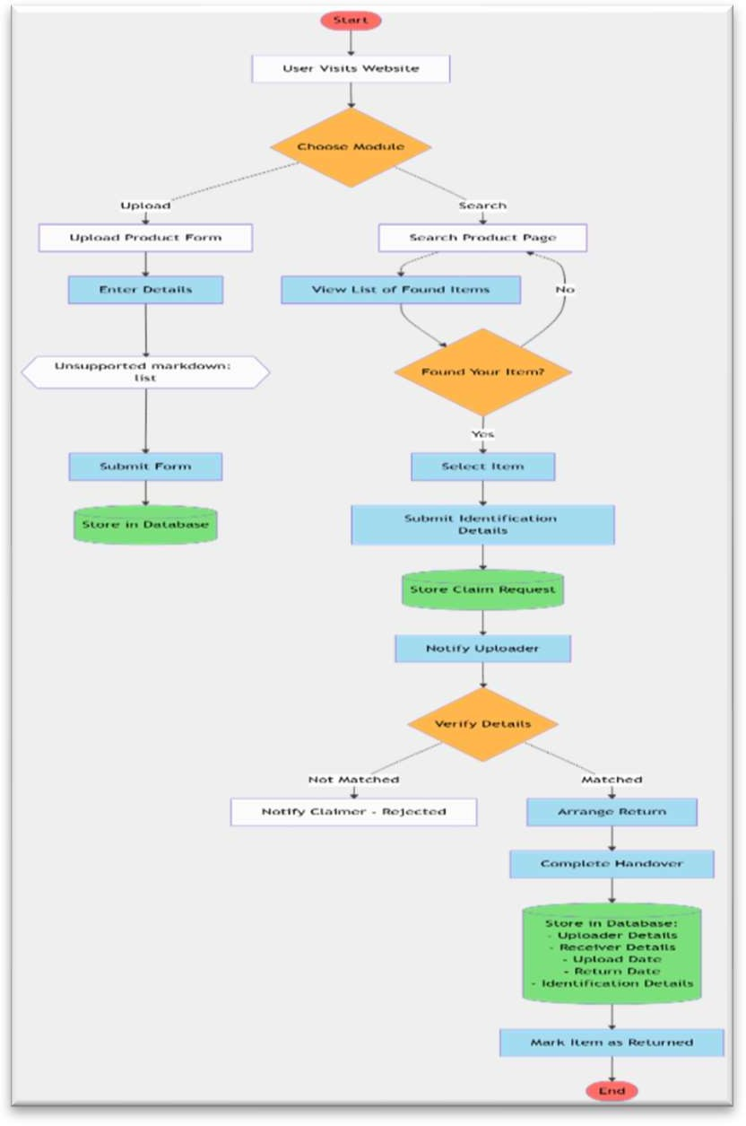To ensure that items are returned to their rightful owners, the system incorporates a **secure verification process**. When a potential match is found, the finder can request additional details from the owner, such as a unique identifier or security question answer, before releasing the item. This step reduces the risk of fraudulent claims and ensures that only verified individuals can retrieve their belongings. For unresolved cases or disputes, an administrative panel is provided where authorized staff can manually verify claims, review item details, and mediate conflicts.

The system’s architecture is designed with scalability and reliability in mind. The back-end processes are hosted on a cloud server to handle increased user traffic efficiently, and the database is optimized for real-time queries and updates. The platform also supports multi-language functionality, ensuring accessibility for a diverse campus community. This flow ensures a seamless and user- friendly experience, reducing the workload of campus administrative staff while offering a secure and efficient solution for lost and found management.

Figure 2: Flowchart

CONCLUSIONS AND FUTURE WORK

*FoundIt: Your Campus Return & Recovery* streamlines the lost and found process on college campuses by providing a secure, user-friendly, and efficient digital platform. Features like real-time notifications, secure verification, and multi- language support ensure accessibility and reliability, while an administrative panel reduces staff workload and ensures rightful ownership of items. By automating manual processes, the system saves time and fosters trust within the campus community.

Future enhancements include integrating **AI- based matching algorithms** for better accuracy, developing a **mobile application** for on-the-go access, and incorporating **GPS-based location services** to pinpoint found items. Additionally, integration with **campus ID systems** and scaling the platform to support multiple institutions would further expand its usability. These improvements will ensure *FoundIt* remains an innovative and adaptable solution for lost and found management.

Acknowledgement

We would like to express our heartfelt gratitude to *Dr. D. Y. Patil Pratisthan’s College Of Engineering, Salokhenagar, Kolhapur.* and the *Department of Computer Science and Engineering* for their guidance and support throughout the development of *FoundIt: Your Campus Return & Recovery*. We extend our sincere thanks to our project mentor, Mrs. Sneha S. Ghewari, for their valuable insights and encouragement, which were instrumental in the successful completion of this project.

We also thank our peers and the campus community for their constructive feedback and suggestions, which helped us shape the platform to meet real- world needs. Finally, we acknowledge the contributions of various resources and research materials that provided a strong foundation for this project. This endeavor would not have been possible without the collective efforts of everyone involved.

Reference

1. N. I. Alnaghaimshi, R. A. Alenizy, G. S. Alfayez, and A. A. Almutairi, "Mafqudat: Arabic Smartphone Application for Reporting Lost and Found Items," *Department of Computer Science and Information, College of Science, Majmaah University*, Al-Majmaah, Saudi Arabia.
2. Pushpa Choudhary, Arjun Singh, Akhilesh Kumar Choudhary, and Arun Pratap Srivastava, "Find Mine: Find the Lost Items via Mobile App," *Department of Information Technology, G. L. Bajaj Institute of Technology and Management*, Greater Noida, India.
3. Peters, J., and Smith, J., "Investigating Strategies for Locating Lost Items in Indoor Environments," *Journal of Behavioral Studies*, vol. 15, no. 3, pp. 120–133, 2018.
4. Lac, J., and Chan, P., "Using BLE Tags for Tracking Lost Items in Outdoor Spaces," *International Conference on Wireless Communication*,

pp. 45–52, 2019.

1. Chan, P., and Wang, H., "RFID and GPS-Based System for Locating Tagged Items," *Journal of Emerging Technologies*, vol. 22, no. 4, pp. 300–312, 2020.
2. UK Finance, "Fraud and Lost Items Report 2018," *UK Finance Publications*, pp. 1–25, 2018.
3. FoundIt Development Team, *FoundIt: System Overview and Features*, Internal Project Documentation, 2024.
4. A. Kumar, R. Gupta, and M. P. Singh, "The Role of Blockchain in Lost and Found Applications," International Journal of Advanced Computing, vol. 34, no. 2, pp. 89-99, 2023.
5. L. Martinez, S. Guo, and C. L. Zhang, "Using IoT for Real-Time Tracking of Lost Items on Campus," Journal of Internet of Things and Smart Systems, vol. 11, no. 1, pp. 42-57, 2024.
6. D. Patel and R. L. Menon, "Efficient Campus Systems for Lost Item Recovery," Journal of Campus Technology Innovation, vol. 27, no. 4,

pp. 205-215, 2024.